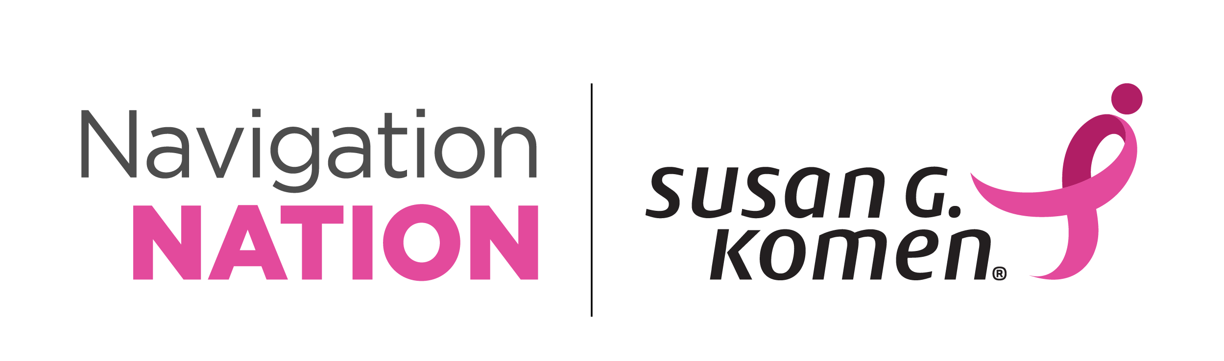
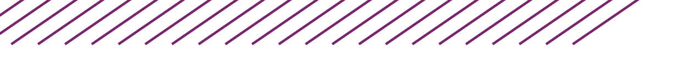

2026 Navigation Nation Summit Program

STRONGER TOGETHER:
The Future of Collaborative Cancer Care





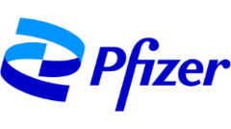
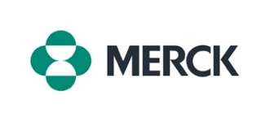


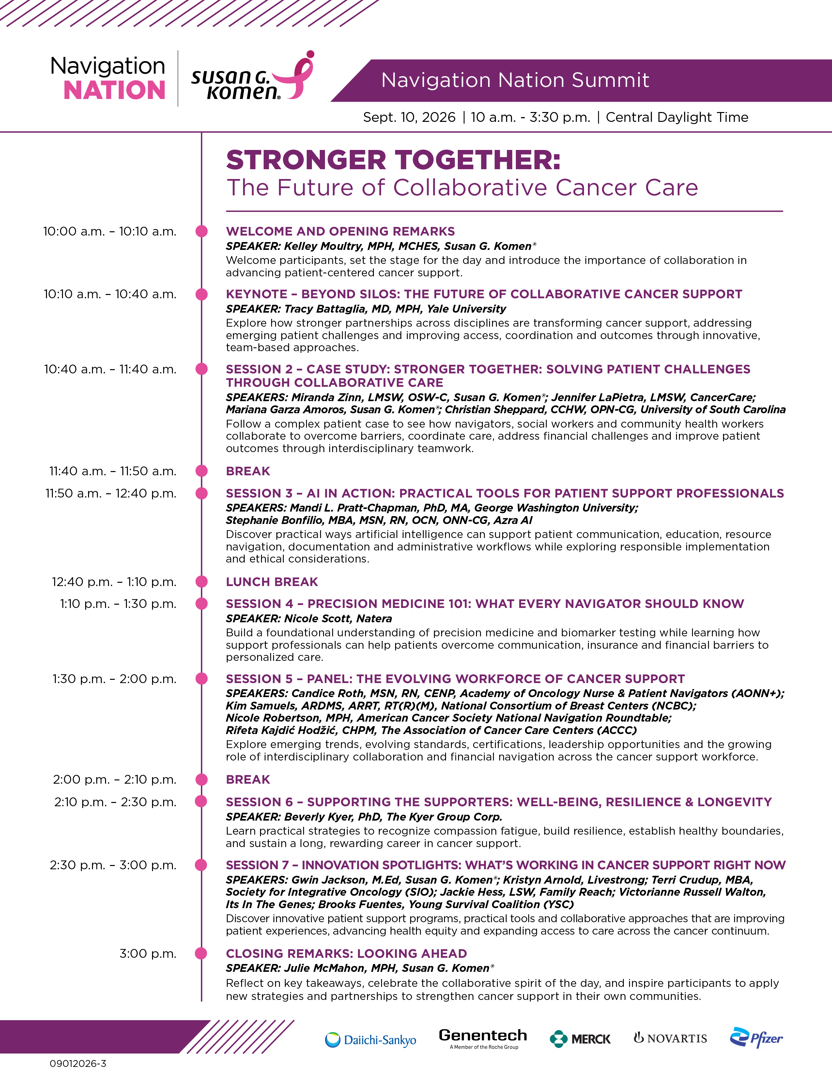

SPEAKER BIOS

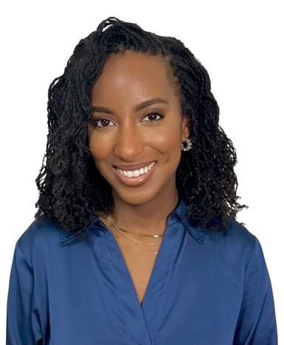
KELLEY MOULTRY, MPH, MCHES
HOST
Kelley Moultry is the program manager of the Community Health Training Program at Susan G. Komen®, where she leads national education and training initiatives to strengthen oncology patient navigation. Kelley holds a Master of Public Health (MPH) with a concentration in health equity from the University at Buffalo and has over 12 years of experience in chronic disease management, patient empowerment and health education. From equipping oncology navigators with the tools and confidence they need to deliver patient-centered care to advancing the standard of care in underresourced communities, Kelley’s work reflects a steadfast commitment to health equity, upholding that every individual has access to timely, high-quality health care and support.

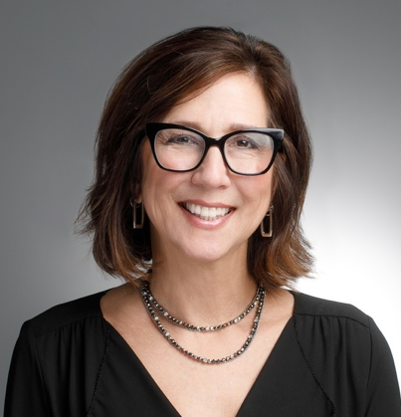
TRACY BATTAGLIA, MD, MPH
KEYNOTE:
Beyond Silos: The Future of Cancer Support
Dr. Tracy Battaglia is a primary care clinician-investigator internationally recognized for her collaborative, innovative approaches to addressing health disparities among women historically marginalized. She has led the development of foundational infrastructure to support community-engaged methods in translational science. Her own research focuses on engaging with community to increase access to care for at-risk women, including groundbreaking work on the role of oncology patient navigators. Through her participation on several National Cancer Institute cooperative groups, she contributed to the 2012 Commission on Cancer Accreditation Standard requiring navigation services in cancer centers. As founding chair of the National Navigation Roundtable, she partners across sectors for sustainable navigation workforce.

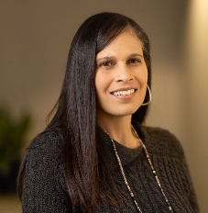
JENNIFER LAPIETRA, LMSW
SESSION: Case Study: Stronger Together:
Solving Patient Challenges Through Collaborative Care
Jennifer LaPietra is the patient assistance program manager and a bilingual oncology social worker at CancerCare. In her role, she helps connect people affected by cancer with supportive counseling, education and financial assistance resources, with a focus on addressing health disparities and barriers to care. Jennifer finds fulfillment in helping clients ease their concerns while discovering their own strengths and resiliency throughout the cancer journey.
Jennifer earned a Master of Science in Social Work with a concentration in advanced clinical practice: aging from Columbia University School of Social Work and a Bachelor of Arts in Psychology from Marist College, with minors in social work and spanish. She is a licensed master social worker and has completed advanced training in grief and bereavement counseling, palliative and end-of-life care, motivational interviewing, trauma-informed care, and culturally responsive cancer care.
An active member of the National Association of Social Workers and the Association of Oncology Social Work (AOSW), Jennifer frequently contributes to patient and professional education through workshops, webinars and conference presentations. Her work has been recognized with CancerCare’s Dorothy Schachne Help & Hope Award in 2024, and she received third-place recognition at the 2026 AOSW Annual Conference for a poster presentation on reducing financial toxicity and improving outcomes for rural and underserved patients.

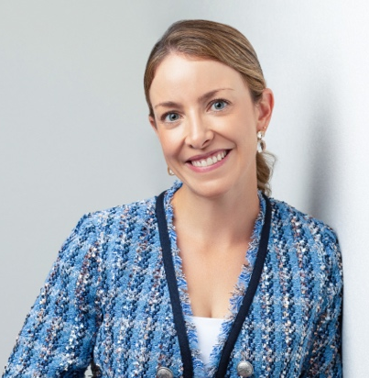
MARIANA GARZA
SESSION: Case Study: Stronger Together:
Solving Patient Challenges Through Collaborative Care
Mariana Garza joined the Komen team as a bilingual patient navigator. She’s originally from Queretaro, a city in Central Mexico. She attended college in Mexico City at Universidad Iberoamericana and graduated with a degree in nutrition and food science. Mariana has focused her professional career in oncology. She moved to Austin in 2010 and has been involved in the cancer fight since. She volunteered at the Livestrong Foundation for two years and later moved on to work at the American Cancer Society for several years. In 2020, when life transitioned into a remote setting, Mariana and her family decided to take one year off to be able to travel around the US and Mexico. Mariana has two kids and enjoys working out and spending time with friends and family.
She loves to run and exercise and gets herself into races that she usually regrets while she’s in the middle of them. She loves snacks, sweet and salty. She would easily replace any meals with just snacks, so likes them all. Her favorite song is Dreams by The Cranberries.
Mariana is passionate about helping others and making a difference in people’s lives.
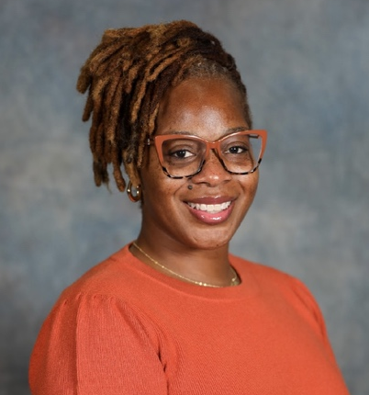
CHRISTIAN SHEPPARD, CCHW, OPN-CG
SESSION: Case Study:
Stronger Together: Solving Patient Challenges Through Collaborative Care
Christian Sheppard is a certified community health worker and oncology patient navigator with nearly 20 years of health care experience. She serves with the Colorectal Cancer Prevention Network at the University of South Carolina, where she supports colorectal cancer screening and follow-up care for underserved communities throughout South Carolina's Lowcountry. Christian is passionate about reducing barriers to care through patient education, navigation and community engagement. She is dedicated to advancing health equity by building trust, fostering collaboration and helping patients navigate the health care system with confidence.

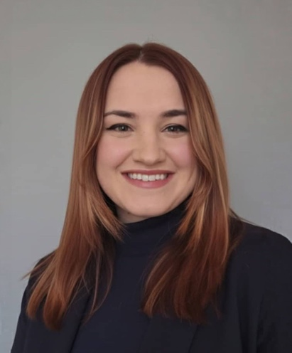
MIRANDA ZINN, MSW, LMSW, OSW-C
SESSION: Case Study:
Stronger Together: Solving Patient Challenges Through Collaborative Care
Miranda Zinn is a licensed master’s level social worker and oncology social work-certified professional currently serving as a Helpline navigator at Susan G. Komen®. With more than seven years of oncology social work experience, she provides emotional support, breast health and breast cancer education, resource navigation, and patient advocacy to individuals and families across the country.
Miranda earned her Master of Social Work from Marywood University and is committed to promoting equitable access to high-quality care through compassionate, patient-centered support. Through her work on the Helpline, she helps patients navigate the emotional, practical and financial challenges that can accompany a breast cancer diagnosis.
Today, Miranda will facilitate a discussion highlighting the unique roles within the cancer care continuum and the ways interdisciplinary teams collaborate to address patients’ needs and improve outcomes.

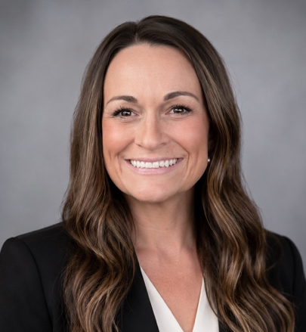
STEPHANIE BONFILIO, MBA, MSN, RN, OCN, ONN-CG
SESSION:
AI in Action: Practical Tools for Patient Support Professionals
Stephanie Bonfilio is the director of clinical advisory services at Azra AI, where she partners with health care organizations to implement and optimize the use of Azra’s AI-driven oncology software platform. With an 18-year nursing career dedicated to oncology, Stephanie has extensive experience across outpatient oncology settings, including roles as infusion nurse, nurse navigator, clinical education specialist, and leader in building and managing a comprehensive patient navigation program at a community cancer center. Most recently, she has focused on empowering organizations to leverage innovative tools and technology to accelerate the advancement of their oncology and navigation programs.
Stephanie is an active leader in the oncology community. She is a national member of the Oncology Nursing Society (ONS) and currently serves as president of her local ONS chapter. She is also deeply engaged with the Academy of Oncology Nurse & Patient Navigators (AONN+), where she serves as co-chair of the metrics committee. A passionate advocate for patient-centered care, Stephanie is committed to improving patient experience and outcomes through data-driven processes, quality-focused initiatives and operational excellence.

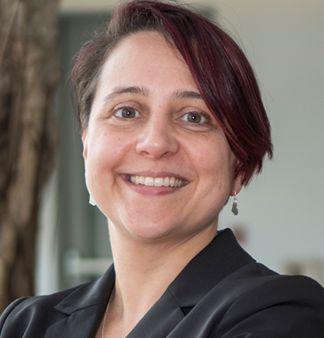
MANDI L. PRATT-CHAPMAN, PHD, MA
SESSION:
AI in Action: Practical Tools for Patient Support Professionals
Mandi Pratt-Chapman is professor of medicine for the GW School of Medicine and Health Sciences, professor of prevention and community health for the GW Milken Institute School of Public Health, and associate center director, scientific communications and dissemination for the GW Cancer Center. Her personal mission is to make evidence-based health care and disease prevention strategies available to more people as quickly as possible. Her research focuses on patient navigation, cancer survivorship, evidence-based cancer control and health equity for intersectional lesbian, gay, bisexual, transgender, queer and intersex (LGBTQI) communities.

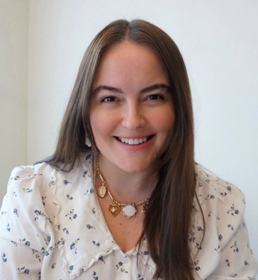
RIFETA KAJDIĆ HODŽIĆ, CHPM
SESSION:
The Evolving Workforce of Cancer Support: Professional Landscape Updates
Rifeta Kajdić Hodžić is assistant director of education at the Association of Cancer Care Centers (ACCC), where she leads the development of national educational initiatives that help cancer programs implement innovative models of care and improve patient access to cancer treatment. Her work spans financial advocacy, precision medicine, bispecific antibodies, CAR T-cell therapy, veterans' cancer care and multidisciplinary care delivery. Through national collaboratives, educational programs, implementation resources and quality improvement initiatives, she partners with multidisciplinary experts to translate emerging evidence into practical, scalable solutions for cancer programs.
Prior to joining ACCC, Rifeta worked in community oncology, specializing in patient access and helping patients overcome barriers to timely cancer care. Her experience across clinical operations and national education provides a unique perspective on the intersection of policy, reimbursement, workflow design and patient-centered care. She is committed to equipping oncology professionals with practical, actionable strategies that improve access, operational efficiency and outcomes for people with cancer.

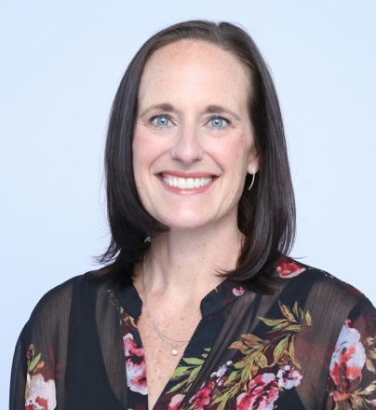
CANDICE ROTH, MSN, RN, CENP
SESSION:
The Evolving Workforce of Cancer Support:
Professional Landscape Updates
Candice Roth brings a strong professional portfolio and deep understanding of oncology nursing and the cancer care continuum to her role as AONN+’s Executive Director. In this position, she is responsible for the development and implementation of AONN+’s strategic vision and growth plan, as well as all operational, financial and technical aspects of the association.
Before joining AONN+ in 2024, Candice served as the executive director of oncology and infusion services at the Medical University of South Carolina’s Hollings Cancer Center. Here, she oversaw the strategic growth and priorities of the center’s oncology service Line as well as the daily operations of the National Comprehensive Cancer Designated Cancer Center, coordinating the health care work delivered by the center’s medical, surgical, radiation oncology programs, infusion services and social work teams.
Over her 23 years as a clinician and administrator, and her 21 years in the oncology care space, Candice has consistently demonstrated proficiency in business development, strategy, budget responsibility, clinical operations, nursing leadership and patient navigation. These skillsets have paved the way for several professional opportunities. Most recently, these include designing and implementing all aspects of a 260,000-square-foot facility expansion, including a Bone Marrow Transplant and Cellular Therapy Program for Atrium Health’s Levine Cancer Institute, where she served as assistant vice president of operations, nursing and quality from 2014 – 2022.
Roth earned her master’s in nursing/education from the University of Phoenix and her bachelor’s in nursing from Avila University in Kansas City, Mo. She is an active member in many professional organizations including the American Nurses Association, American Organization of Nurse Executives, American Organization of Nursing Leadership, Oncology Nursing Society and American College of Healthcare Executives. Through these affiliations, she has had the opportunity to advocate on behalf of her profession and patients locally and statewide.
Candice resides in Gainesville, Fla., with her husband, Ché, and two children, Cash (16) and Cayden (15), along with an energetic 9-year-old Siberian Husky, Wrigley. When not working, she enjoys traveling, reading and spending quality time with her family in Tybee Island, Ga.

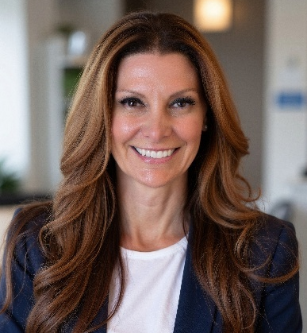
KIMBERLY SAMUELS, MBA, RT(R)(M), ARRT, ARDMS
SESSION:
The Evolving Workforce of Cancer Support:
Professional Landscape Updates
Kimberly Samuels is the chief executive officer of the National Consortium of Breast Centers (NCBC), a national interdisciplinary organization dedicated to advancing excellence in breast care through education, certification, quality improvement and collaboration. During more than 13 years with NCBC, she has led the growth of nationally accredited certification programs, workforce development initiatives, the National Quality Measures for Breast Centers (NQMBC) and year-round professional education. Her work brings together navigators, clinicians, program leaders, advocates and industry partners to strengthen coordinated, patient-centered cancer care. Kimberly is especially focused on building sustainable professional pathways for navigation and interdisciplinary care teams translating standards into practical improvements for patients and care teams.

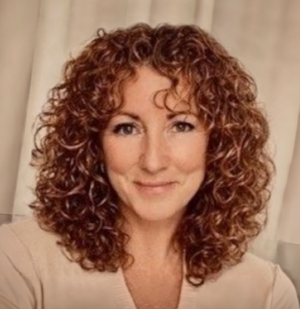
NICOLE ROBERTSON, MPH
SESSION:
The Evolving Workforce of Cancer Support:
Professional Landscape Updates
Nicole Robertson is the director of navigation operations at the American Cancer Society. With over 15 years of experience, she leverages expertise in people leadership and project management to enhance care delivery systems. In her current role, Nicole empowers teams and fosters strategic initiatives to improve cancer navigation services. Previously, she supported cancer center partnerships and strategic initiatives. She is passionate about health equity and organizational impact and focuses on operationalizing strategies that align with the mission of improving patient outcomes.
Prior to her current position, Nicole held several leadership roles within the American Cancer Society, including associate director, cancer center partnerships and senior manager, cancer control strategic partnerships. She holds a Master of Public Health from Portland State University and a Bachelor of Science from the University of Wisconsin-Madison.
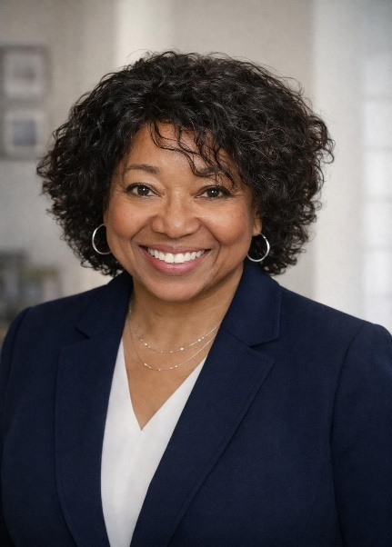
BEVERLY KYER, PHD
SESSION: Supporting the Supporters:
Well-Being, Resilience & Longevity
Beverly Kyer has been a public speaker, trauma specialist and educator for more than 43 years, with specialties in post-traumatic stress disorder; the trauma Impact on brain development, behavior and learning in children, youth and adults; and compassion fatigue, AKA secondary or vicarious trauma.
Beverly has served as a readjustment counseling therapist for Vietnam veterans in Operation Outreach, EAP (Employee Assistance Program) coordinator and assistant chief of social work services at the Bronx, N.Y., Veterans Administration Medical Center. She has served for several years working with children and families receiving medical and psychiatric care, pediatric oncology, and those in juvenile justice and the foster care systems.
She is a certified compassion fatigue specialist and is the founder and former CEO of The Kyer Group Corp., a team of compassionate trauma-informed specialists, who train and support helping professions. The KGC has since pivoted and rebranded to the Wellness Reset Campus,
Beverly provides on-site and virtual training internationally with a mission to educate, inspire and support recovery, resilience, capacity, effectiveness and determination for professional service providers and family caregivers to the physically and mentally challenged, the victimized, traumatized and most vulnerable in society – our children.
Roles in her career include trainer, educator, therapist, psychiatric and medical social worker, social work field placement supervisor for Columbia University, program coordinator, social work supervisor, assistant chief of service, and grief & loss and trauma-informed educator, consultant. Beverly served for several years as an instructor at UC Davis Extension and the University of Nevada School of Social Work, Reno, Nev.
Beverly’s participatory training style creates an interactive and collaborative learning environment focused on seeking answers and promoting effective quality service delivery and self-care via her Healthy Workplace Initiative.

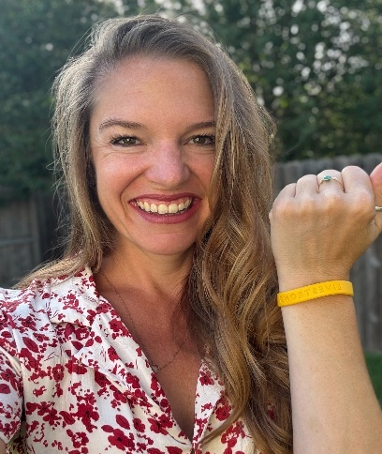
KRISTYN ARNOLD
SESSION: Innovation Spotlights:
What's Working in Cancer Support Right Now
Kristyn Arnold serves as director of mission & impact at Livestrong, where she champions innovative programs and partnerships that support individuals affected by cancer. A solutions-driven collaborator, she is committed to building sustainable communities and advancing Livestrong’s mission to ensure that people impacted by cancer not only survive but thrive.
Passionate about creating meaningful impact, Kristyn helps drive initiatives that reflect Livestrong’s legacy as a global symbol of hope and inspiration. She holds a bachelor’s degree in social work from the University of Mary Hardin-Baylor and brings a strong commitment to service, advocacy and improving the cancer experience for patients, survivors and their families.

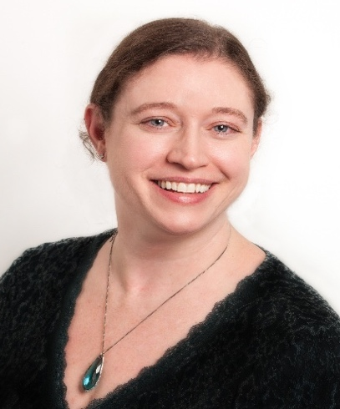
TERRI CRUDUP, MBA
SESSION: Innovation Spotlights:
What's Working in Cancer Support Right Now
Terri Crudup is an integrative oncology researcher, author, educator and patient advocate. After her second bout with breast cancer in 2019, she started volunteering with the Society for Integrative Oncology (SIO) and is currently co-chair of the education committee, a member of the patient advocate committee and the lead author on SIO’s patient-facing eBook Taking Care of the Whole You. Terri also works as a project coordinator on the IMAGINE Project, implementing massage and acupuncture for the management of cancer-related pain across 35 US cancer centers. Terri has authored several publications on integrative oncology and speaks regularly at events to educate and empower patients.


BROOKS FUENTES
SESSION: Innovation Spotlights:
What's Working in Cancer Support Right Now
Brooks Fuentes (she/her) is a program associate for community support at Young Survival Coalition (YSC), a national nonprofit supporting young adults affected by breast cancer. Her perspective is shaped by a two-generation experience with breast cancer — first as the daughter of a mother diagnosed with metastatic disease and later through her own early stage diagnosis at age 36. She previously served as special programs coordinator at Breast Friends, where she established and led the organization's Latine/Hispanic program. Brooks brings a background in social science and UX design to translating patient experience into accessible, actionable support. A 2026 cohort member of the Latino Cancer Patient Advocate Training Program, she is dedicated to amplifying underrepresented voices and advancing equitable, culturally responsive survivorship care, and has presented and moderated on AYA (adolescent and young adult) and LGBTQIA+ cancer topics in coalition settings. She loves creating spaces of healing and connection for survivors and thrivers, and serves as a volunteer YSC state leader and face 2 face coordinator.

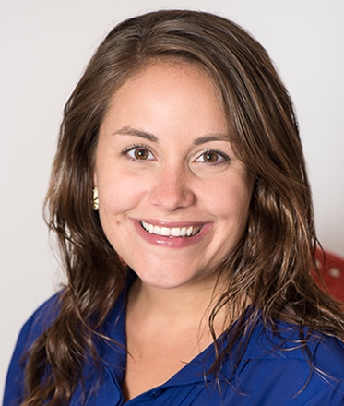
JACKIE HESS, LSW
SESSION: Innovation Spotlights:
What's Working in Cancer Support Right Now
Jackie Hess is the senior director of programs at Family Reach, where she leads initiatives that help to remove the financial barriers that stand between cancer patients and their treatment. A licensed social worker with over a decade of experience in nonprofit program development and management, Jackie is a strategic leader known for driving innovation, scaling impact and building programs that meet patients where they are.
She leverages data, partnerships and strategic planning to strengthen outcomes and maximize resources, translating complex challenges into actionable solutions while keeping the patient experience at the center of the work. Passionate about health equity, Jackie is committed to advancing solutions that make cancer care more accessible for all. When she's not working to eliminate financial obstacles to cancer care, you can find her getting her hands dirty on her family farm in northern New Jersey.

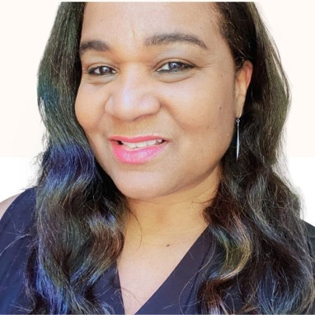
GWIN FLOWERS JACKSON, M.ED
FACILITATOR
SESSION: Innovation Spotlights:
What's Working in Cancer Support Right Now
Gwinnett (Gwin) Flowers Jackson serves as program coordinator for community health training at Susan G. Komen®, where she develops and leads oncology patient navigation training and coaching initiatives. An experienced educational strategist, she brings extensive expertise in designing, coordinating, and facilitating impactful learning experiences for adult and professional audiences.
Drawing on a diverse background in oncology navigation, health care IT, behavioral health, health literacy, workforce development and digital education, Gwin employs a learner-centered approach that prioritizes clarity, accessibility and practical application within real-world health care environments.
Her expertise includes translating complex concepts into engaging, meaningful educational content and guiding diverse audiences, including health care professionals, patients and providers, through onboarding, professional development, upskilling and virtual learning initiatives. Throughout her career, she has led training and development efforts across both clinical and non-clinical settings, adapting educational strategies to support evolving technologies, processes and workforce needs.
Whether supporting small teams or large-scale organizational initiatives, Gwin brings a thoughtful combination of structure, insight and empathetic listening, helping individuals and organizations achieve meaningful growth and lasting impact.

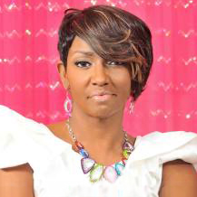
VICTORIANNE RUSSELL WALTON
SESSION: Innovation Spotlights:
What's Working in Cancer Support Right Now
Victorianne Russell Walton is an award-winning, two-time breast cancer survivor, breast cancer advocate, motivational speaker, radio host, lifestyle coach, chronic disease instructor and oncology patient navigator trainer. A dedicated advocate since 2007, she transformed her own challenging cancer journey, including multiple misdiagnoses, extensive treatment and significant health complications, into a mission of education, empowerment and support for others facing cancer.
Drawing from her lived experience, Vicki has become a respected voice in the cancer community. Her advocacy work includes serving on research and community health initiatives, creating the Breast Cancer Chat and Chew Project, supporting cancer ministries and cancer centers, and partnering with organizations focused on survivorship, health equity and patient support. Through her speaking, coaching and leadership, she continues to inspire individuals to navigate cancer and chronic disease challenges with resilience, hope and purpose.
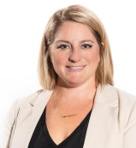
JULIE MCMAHON, MPH
Closing Remarks
Julie McMahon is director of community health programs at Susan G. Komen®, where she leads national efforts to improve access to breast cancer care for underresourced communities. She helped launch Komen’s telehealth navigation model and directs initiatives such as the Patient Navigation Training Program, which has reached more than 2,000 navigators. Julie holds a Master of Public Health in Epidemiology from The Ohio State University and a Bachelor of Artis in Political Science from Denison University. Her expertise spans health equity, patient-centered care models, culturally responsive programming and public policy advocacy. She has authored multiple publications on navigation standards and metastatic breast cancer and serves in national leadership roles with the National Navigation Roundtable. Julie received the 2024 AONN+ Ambassador Award for her work in community health.

Navigation Nation Training Program
The Susan G. Komen® Navigation Nation Training Program is a cornerstone resource for professionals dedicated to helping individuals navigate the cancer care continuum. Designed for patient navigators, social workers, community health workers, nurses, advocates, and other patient support professionals, Komen's free program equips new professionals with foundational knowledge while providing experienced practitioners opportunities to deepen their expertise, strengthen their practice, and advance their careers.

More than just training, it's a thriving professional community known committed to collaboration, professional growth, and health equity. Participants can explore tailored learning journeys designed to meet them where they are, from foundational skills to advanced practice, and utilize a self-assessment tool to identify the learning path best aligned with their role and experience. Through specialized educational content, peer-to-peer connection, and practical resources, the program empowers patient support professionals to enhance the care experience and make a meaningful impact in the communities they serve.

Join and learn more at komen.org/navigationnation.

RESOURCES
Sponsor Resources:
Genentech Patient Support Services
Merck Finding Treatments Together - for Hispanic & Latino Community | Spanish
Merck Finding Treatments Together - For Africian American Community | Spanish
Novartis – A Guide to Understanding Metastatic Breast Cancer
Novartis - A Guide to Understanding Early Breast Cancer
The AI Toolbox: How to Use AI as a Resource - Susan G. Komen®
Your Breast Cancer Team
AI, Technology, and Data Justice
Using Artificial Intelligence (AI) to Find Breast Cancer Clinical Trials

REQUENTLY ASKED QUESTIONS

When and where will the summit be held?
We are excited to hold the Navigation Nation Summit via the Zoom meeting platform on Thursday, Sept. 10, 2026.

How can I download Zoom?
Zoom is available for free download on Windows, iOS and as a mobile app on both Apple and Android devices. To download Zoom on your computer, visit https://zoom.us/download. To download Zoom on your smart phone, visit your app store and search for “Zoom.”

What if I didn’t receive a Zoom link after registering?
You should have automatically received a Zoom link after registering. If you didn’t receive a Zoom link, reach out to navigationnation@komen.org.

What if I have trouble logging into the summit?
As a best practice, try restarting your computer prior to logging into Zoom. If you continue to have issues, visit this troubleshooting page on Zoom’s website.

Will the sessions be recorded?
Yes, all summit sessions will be recorded and posted on Komen’s Navigation Training Portal for members of our training community. Contact navigationnation@komen.org to become a part of the Navigation Nation community, where you can access more free courses, trainings and resources, and connect with other professionals and patient advocates.

Is the summit continuing education?
Documentation of participation in the summit can be submitted to support “on the job” experience requirements to pursue accredited certification under National Consortium of Breast Centers. The Academy of Oncology Nurse & Patient Navigators (AONN+) will accept verification of participation toward the continuing education requirements for AONN+ certification (non-accredited). If you are a patient navigator and need verification for pursuing or maintaining certification, or for your employer, please reach out to navigationnation@komen.org.

What is Komen’s Navigation Nation Training Community?
Komen’s supportive, interactive Navigation Nation learning community is designed to enhance professional skills, provide a peer network and support system, and give patient support professionals tools and resources to meet the needs of those experiencing breast cancer inequities. Patient support professionals can now explore tailored learning journeys and use a self-assessment tool to find the path that best fits their role and experience. Click here to learn more.

KOMEN RESOURCES
Komen Resources for Your Practice
Susan G. Komen® offers many resources to support you and others at the point of care.
We have a robust collection of downloadable and printable breast health resources available on the educational resources page of komen.org. We also have a wealth of direct patient service and education programs, which are listed below:

Patient Care Center: Offers virtual, bilingual navigation services to help patients overcome non-clinical barriers, complementing existing provider-based navigation, and extending support to those without access to navigation. By partnering with Komen, health care professionals can ensure their patients receive personalized, high-quality, whole-person support — including assistance navigating clinical trials — even when site-based navigation isn’t available.

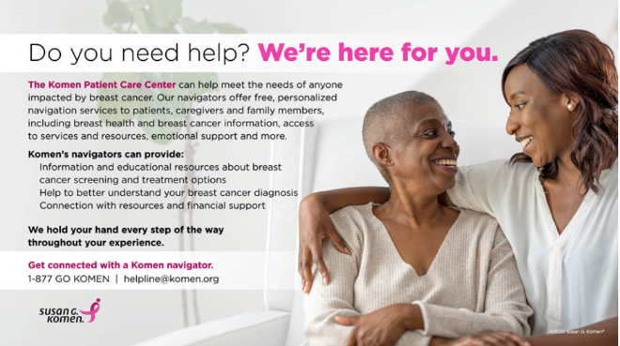

Metastatic Breast Cancer Series provides people living with metastatic breast cancer and their loved ones a safe, collaborative space to gather information related to MBC and discover practical resources to help make decisions for improved physical and emotional health.

Worship in Pink Program: A volunteer-driven breast health educational program powered by local faith-based communities. The time, support and creativity of volunteer Worship in Pink Ambassadors like YOU is key to the success of the program!

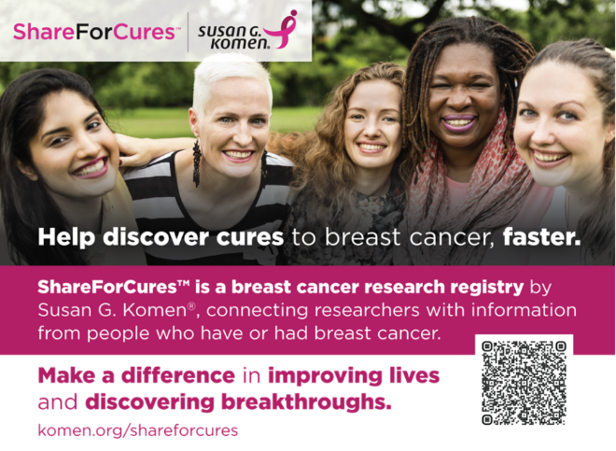

ShareForCures®: A breast cancer research registry by Susan G. Komen®, connecting researchers with information from people who have or had breast cancer. ShareForCures is an IRB-approved study, registered on clinicaltrials.gov and an opportunity for providers to increase the number of patients at their sites recruited to clinical study.

“Breast Cancer Breakthroughs” series: To answer the question of “What’s next for breast cancer patients?” Susan G. Komen® is proud to present the Breast Cancer Breakthrough Series: a virtual, shareable educational series in partnership with industry experts, scientists from academic institutions and patient advocates who will directly speak to recent clinical research findings and new treatments. This series will focus on the new science and technologies that are close to becoming available to patients.

“Know More”: You shouldn’t need a medical degree to understand your breast cancer diagnosis. Komen’s Know More series brings you what you need to know about your breast cancer diagnosis and empowers you to face it head on.

“What’s New In Breast Cancer”: This section gives an overview of new breast cancer treatment breakthroughs and recent developments in research that are fueling new ways to assess risk, and prevent, detect, diagnose and treat breast cancer.
Spotlight on Clinical Trials: This educational series features blogs, podcasts and downloadable resources on clinical trials and specific trials.

Komen en Español: Educational resources and tools in Spanish.

Inflammatory Breast Cancer (IBC) Scoring System: The Inflammatory Breast Cancer (IBC) Scoring System is a proposed set of common diagnostic criteria designed for health care providers to identify IBC. It is being developed to increase diagnostic accuracy, guide treatment decisions and inclusion in clinical trials, and aid basic research.

Research Education and Advocate Community Hub (REACH): An advocate community for people to stay up to date about advancements in research, receive trusted information about breast cancer and learn about ways to get involved. REACH community members will receive periodic updates on Komen’s research programs and initiatives and learn how research is making an impact for patients. You don’t need a scientific background or knowledge in research to join this advocate community. All patients, survivors and co-survivors are welcome. REACH members can become more actively involved in Komen opportunities or engagements based on their interests and availability.

THANK YOU TO OUR SPONSORS

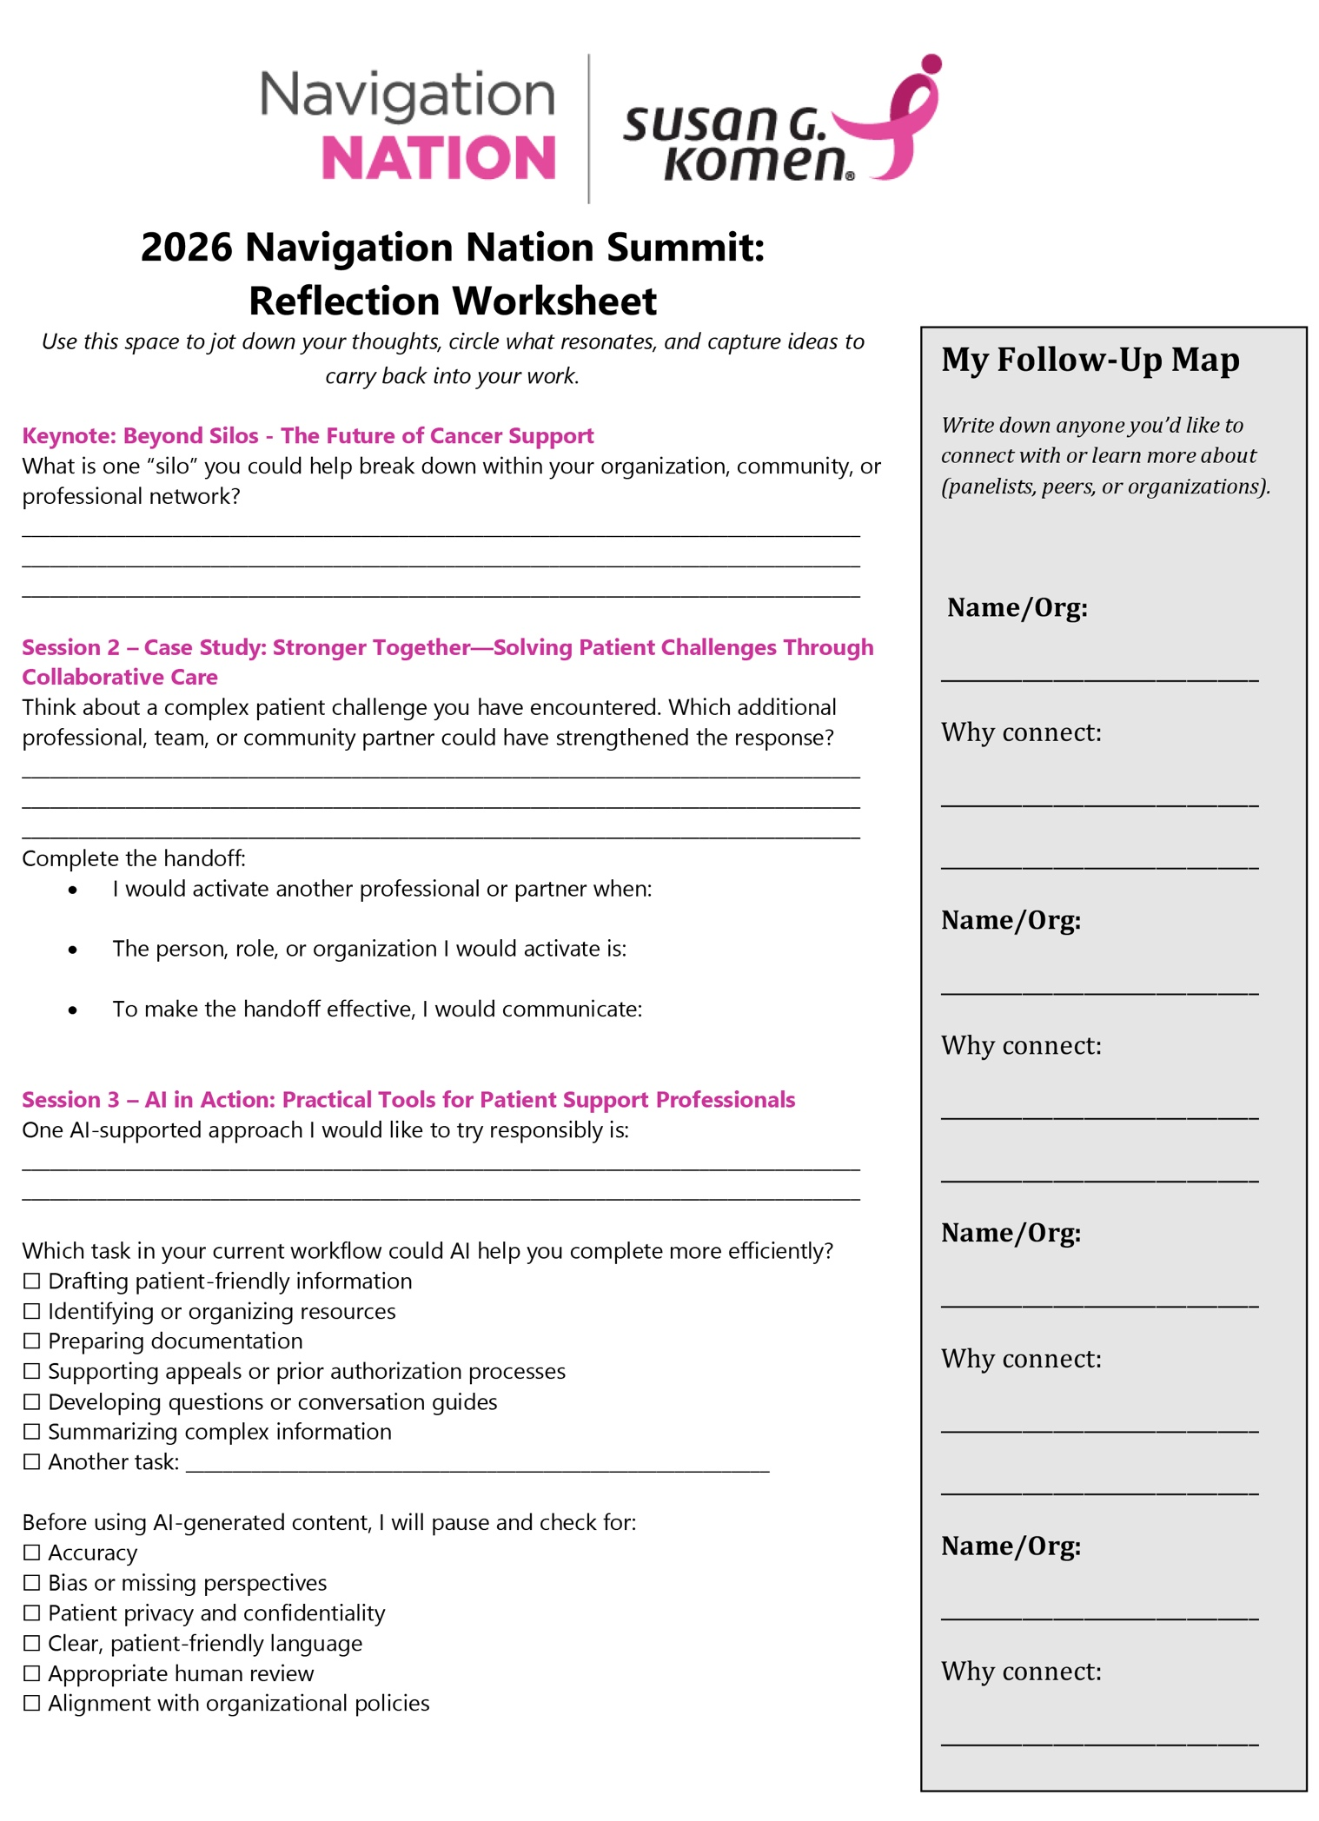

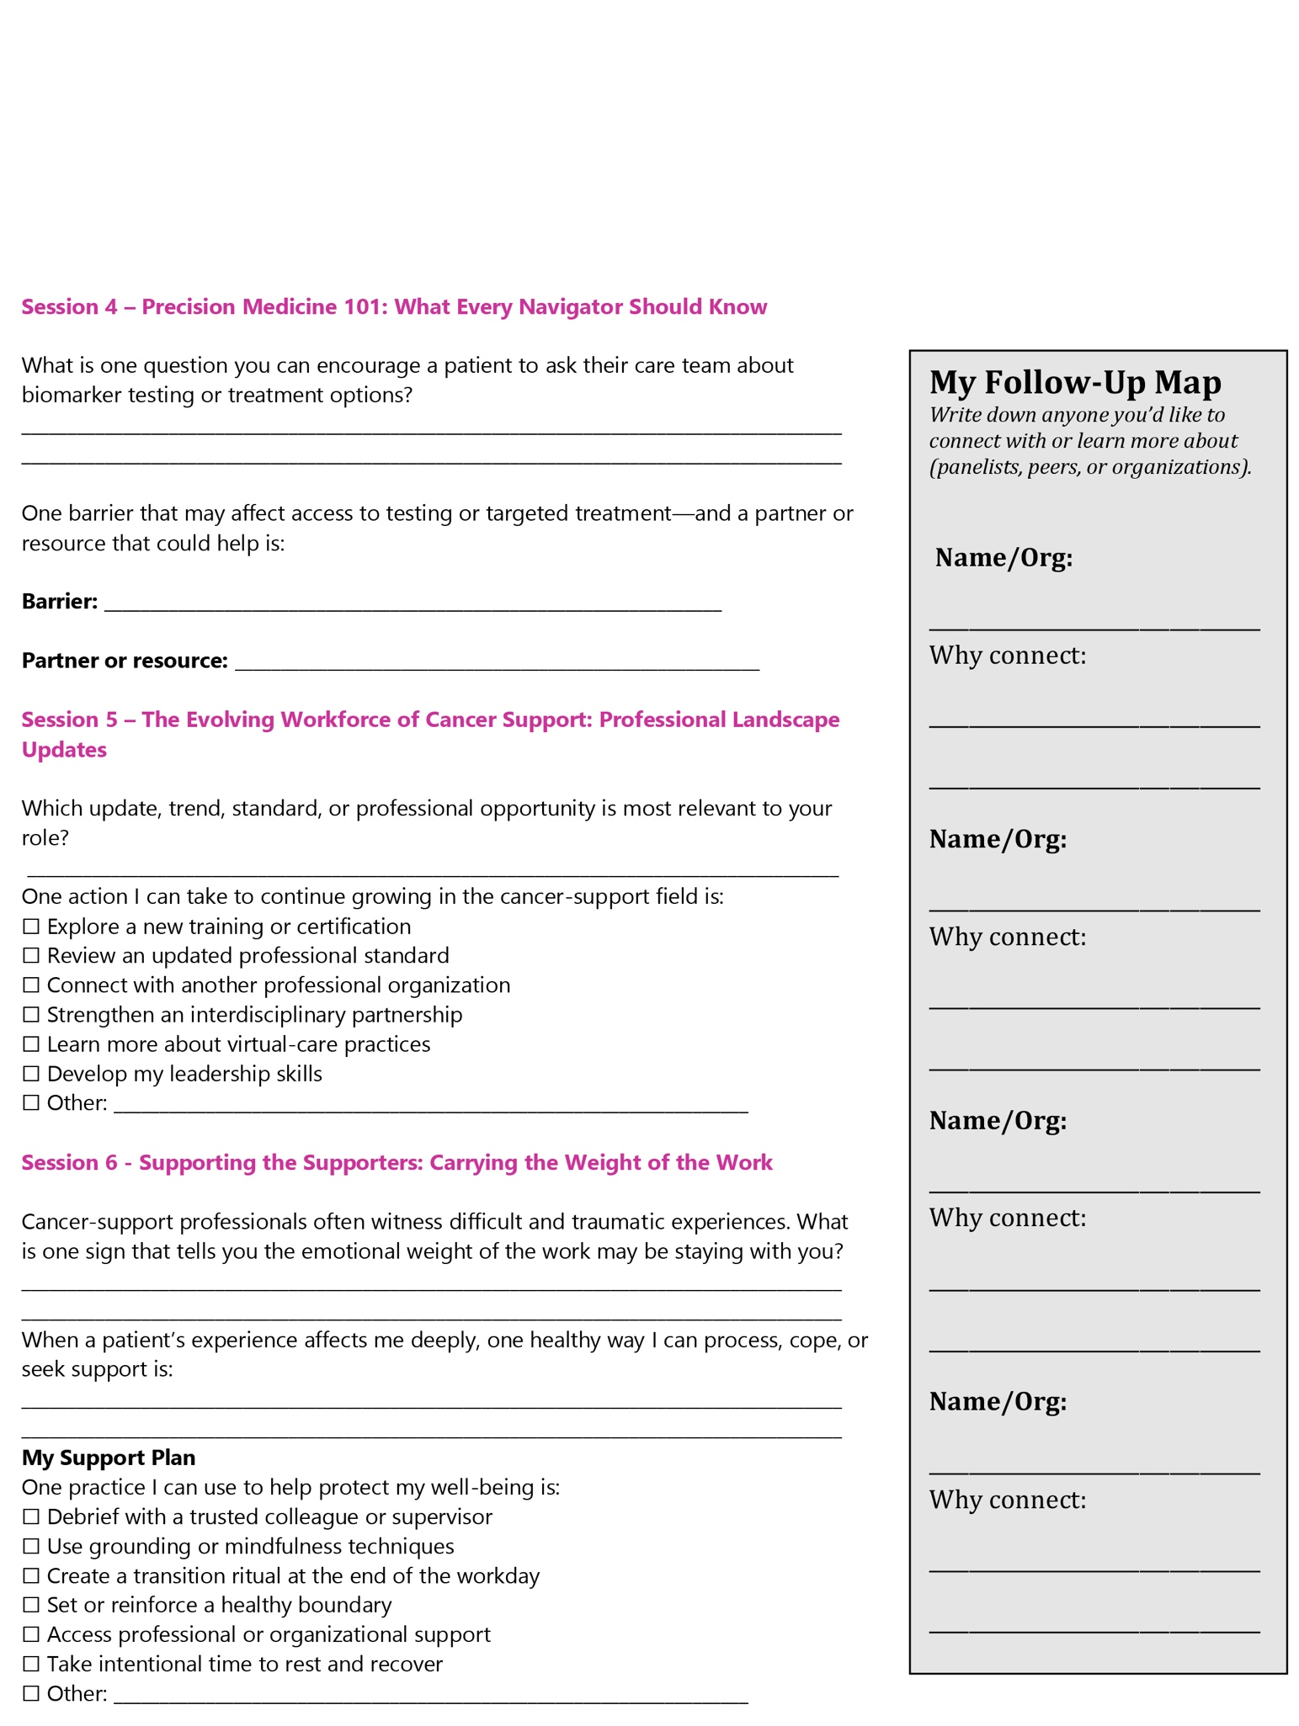

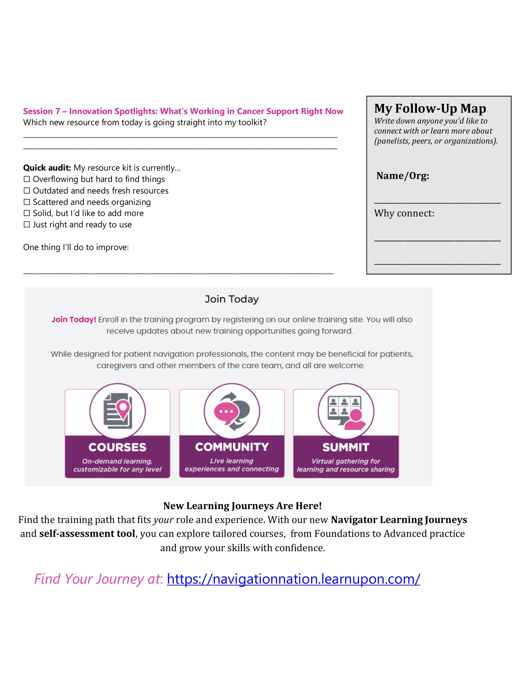
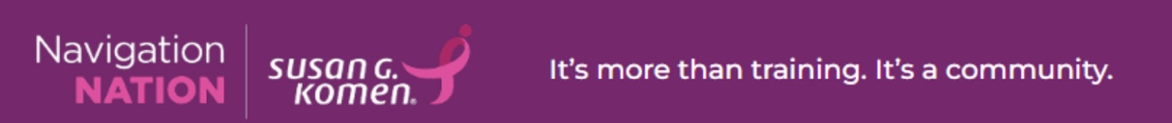
Find Your Journey at: https://navigationnation.learnupon.com/

